Technical Manual for Hermes System
By Michael L. P. McNamara, Anthony Pitluga, Yai Oladokun Laleye
April 15, 2004

Overview
This document describes in detail, how a system must be setup so as to be able to successfully run the Hermes system.

System Requirements
- Intel® Pentium® II/233MHz or compatible
- Microsoft® Windows® 2000 (SP2), XP, or NT 4.0 (SP6a)
- Microsoft® Access® 2000 or later
- A Java Development Kit: Borland JBuilder (Standard, Personal or Enterprise Edition) IDE or JDK 1.4.1(for running Hermes in command line)

3. Assumptions
- It was assumed that all system requirements have been met except from the installation of a Java Development Kit.
- It was also assumed that the Hermes system has been pre-packaged on a CD or any other storage medium.

4. Installing Java Development Kit
4.1 Installing Borland JBuilder
- Simply insert installation CD
- Follow installation instruction until installation is complete.

4.2 Installing JDK
This provides for being able to run Hermes from command line. JDK unlike JBuilder can be downloaded freely online. In order to get JDK, follow the steps:

- Download JDK 1.4.2 from http://www.java.suns.com
- Run the Java J2SE Installer
  - If while downloading, the “open” option was selected instead of the “save” option then after downloading, SDK Installer starts up automatically.
  - If while downloading the “save” option was selected, an executable file would be saved on the selected drive. Double click on this file to run Installer.
  - Whatever the case, follow instructions of the Installer.
  - Installer may request that the computer be rebooted.

5. Setting the path
After installation is complete, we need to set the path for convenience. This could be done using one of the following two ways:
- Create a batch file
  - Create a new note pad file
  - Type in the following command
PATH=C:\j2sdk1.4.2_04\bin;
Depending on the version of JDK being installed, the command will vary.
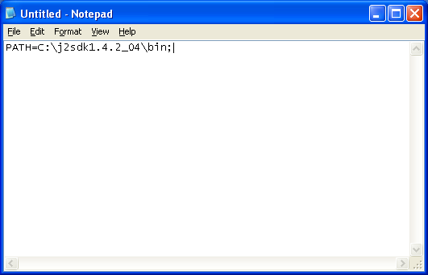
  - Next we proceed to saving the file with the extension “.bat” and hit save.
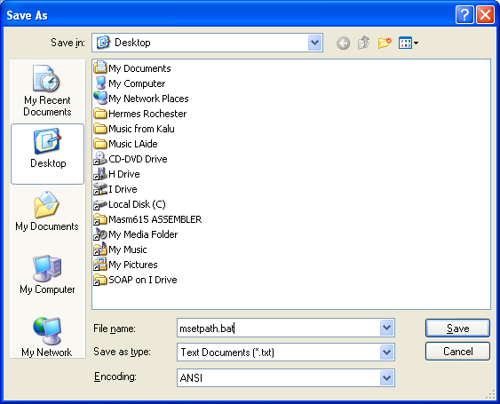

  - Next, close the file, then go and double click on it. This will automatically set your path.
  - Note that the command placed in the batch file could be typed directly in command line. However the case, both are temporary and whenever the system reboots, path has to be set again.

- The second way of setting the path, sets the path permanently:
  - Click Start → Settings → Control Panel
  - Double click on System. Select the Advanced tab then click on Environment Variables
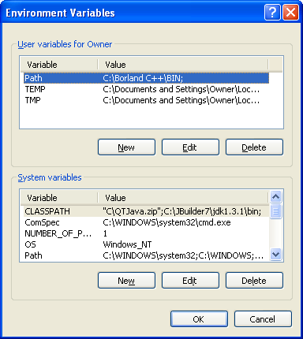
  - Next double click on path or click on path and then click Edit
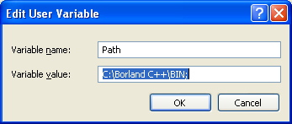
  - Update the Variable value field with the path. If you are sure of were to insert it, simply append it to the very end of the previously existing paths.
  - Close command prompt and reopen it and the path set will take effect.

6. Copying Hermes Files
At this point, Hermes files, Hermes.jar will be copied from the medium on which it was saved to the Hard disk of the machine.

7. ODBC Data Source Configuration
# | Data Source Name | File Name
1 | E-IntraCarrier | IntraCarrier.mdb
2 | E-IntraShips | IntraShip.mdb
3 | E-RegisterShipCarr | RegisterShipperCarrier.mdb
4 | E-TransMainDB | MainDatabase.mdb
5 | E-TransShips | Shipper.mdb
6 | E-TransTrucks | Carrier.mdb
In order to configure the data sources:
- Open the control panel by clicking on Start->Settings->Control Panel.

- Double click on Administrative tools. A window will pop up.

- Right click anywhere in the window and select ODBC Administrator. The ODBC Data Source Administrator window should pop up.

- Click on the Add button and select the Microsoft Access Driver (*.mdb) option and then click Finish.
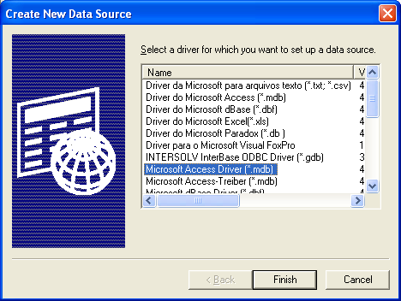
- In the Data Source Name text field, type in E-IntraCarrier and then click the Select button.

- Navigate to the directory in which the database files are located and select IntraCarrier.mdb then click OK buttons (should be two) until you reach the ODBC Data Source Administrator window.
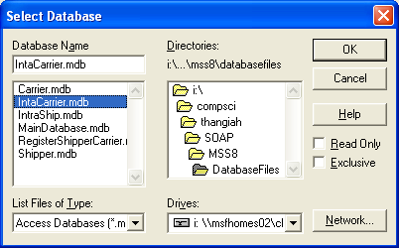

- Repeat step 4-6 for each of the database files listed in the configuration table.
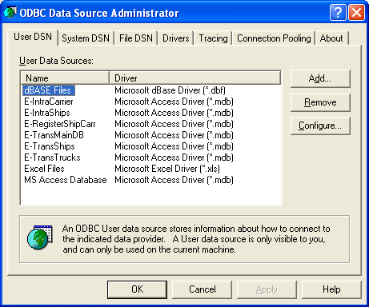

8. Running Hermes

8.1 Using JBuilder
- Open Hermes project file Hermes.jpx in JBuilder (Standard or Enterprise Edition).
- Be sure that the JUnit.jar files are part of the class path.
  - Click on the Project menu option and select project properties.
  - Click on the Required Libraries tab and see if the JUnit library is present.
    - If not, then click on the Add button.
    - Select from the list the missing library packages.
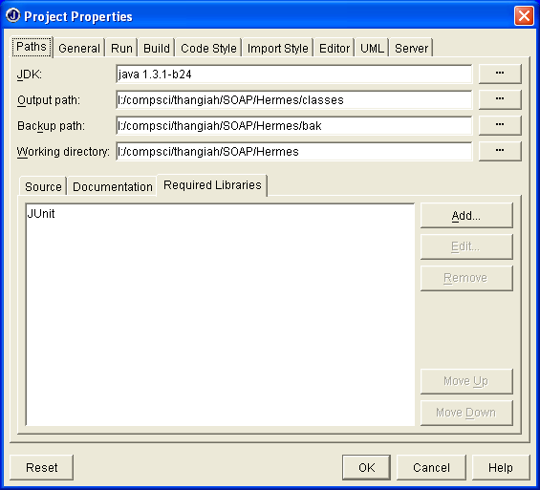

- For each of the classes with a main Eg. Master.java, Shipper.java, Carrier.java, create a Runtime configuration. For example for the MasterServer :
  - Click on the Project menu option and select project properties.
  - Click on the Run tab and then click on New
    - Enter the run configuration name desired
    - Select the file with main class. In this case Hermes.Master
    - If there are any command line parameters, enter them in Application Parameter field.
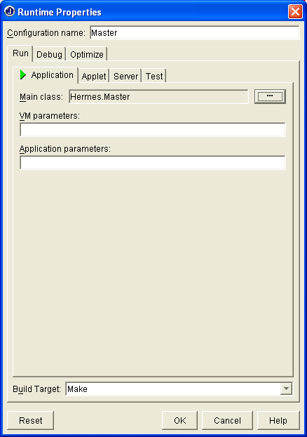
  - Repeat steps 3a and 3b for Carrier.java and Shipper.java .

- To Start the Hermes project
  - Click on the Run Project button in the tool bar
  - Or click the Run menu option and select Run Project
  - Or press the F9 key on the keyboard.
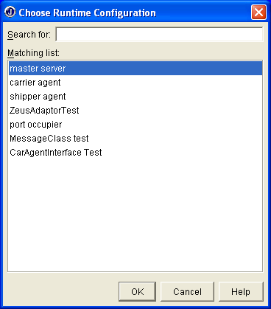
  - Select the class (agent) to run and then click OK. Note: ALWAYS start with the Master. Then follow it up with any other agents.

8.2 Using Command Line
In order to run Hermes from the command line, follow the following steps:
- Set the class path
JDK has to able to locate all the packages to used for running Hermes. These include the Hermes.jar files and JUnit.jar files. The path through which the JRE (Java Runtime Environment) searches for such third party or user-defined packages and classes is known as the classpath.
  - Open Command prompt and type in the command
set classpath= path1;path2;….pathn;
Then hit enter.
The above command will set the classpath to the specified paths including the current folder because of the “.;”.
Note: This will only set class path temporarily while command prompt is open.
  - To set class path permanently do the following
    - Perform steps 5.2a and 5.2b
    - Double click on class path or select class path the hit Edit
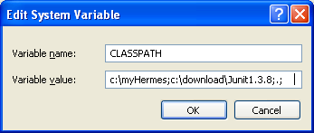
    - Edit the Variable value field by appending to the end of the string the necessary path or paths.
- Compile in command prompt each class using
c:\javac ClassName.java
- Run each class using
c:\java ClassName
- To obtain documentation for the various classes
c:\javadoc ClassName

9. Hermes Classes
CarrierAgent.java – Carrier Agent main class; has access to the CarrierAgentInterface.java class that contains all of the functionality for initiating user events for the carrier agent.

CarrierAgentInterface.java – has an instance of the Zeus System, which handles the schedule of the Carrier Agent; gives capability to register with the Master Server, to optimize the schedule through the Zeus system, and allows the schedule to be displayed to the user.

CarrierDatabaseInterface.java – handles all the database functionality for the carrier agents.

CarrierMessageHandler.java – this class receives a message over a socket and processes it accordingly.

CarrierMessageListener.java – this threads listen for connections and spawns a new thread (a socket) when a new connection comes in.

DatabaseInterface.java – provides a default communication platform for database interaction.

HermesGlobals.java – holds global variables that are used by the entire system.

Master.java – Main class for the Master Server; has access to the MasterAgentInterface.java class.

MasterAgentInterface.java – allows the solution to be printed to the user, the schedule to be optimized by intra-carrier and inter-carrier optimization, and to terminate the system.

MasterMessageHandler.java – handles all incoming messages to the master server.

MasterMessageListener.java – thread that will listen for incoming messages to the master server.

MasterServerShipment.java – this is the data structure for a shipment when it is being held on the master server.

Message.java – this class provides XML messaging without exposing the user to any of the XML details.

MessageTags.java – This interface class contains the various attributes used for message tags during communicating amongst the various agents (shipper, carrier, and Master Server).

RegisterShipperCarrierDatabaseInterface.java – provides an interface to the Registered shipper and carriers database.

ShipperAgent.java – Shipper Agent main class; has access to the ShipperAgentInterface.java class.

ShipperAgentInterface.java – class that is responsible for all of the functionality of the Shipper Agent, for example: opening the problem file and sending the customers for auctioning.

ShipperDatabaseInterface.java – handles all communication between the shipper and the databases.

ShipperMessageHandler.java – this class receives a message over a socket and processes it accordingly.

ShipperMessageListener.java – thread that will listen for connections on the shipper's port, and spawn other threads to handle the messages

ThreadedClient.java – threaded class that will send messages to the other agents.

ZeusAdaptor.java – this is the adaptor class to interface the Carrier agent with the Zeus System.

10. Interactions between Hermes Classes
Shipper to Master Interactions
- Shipper registers with Master by sending a registration message using the registerShipperWithMasterServer() method.
- Shipper sends customers/shipments that are up for bids to the Master for broadcasting using the sendCustomersToMasterServer() method.
- After bids have been returned, and the shipper has decided the best bid using the setCostSendPoint() method, shipper sends an offer to the winning Carrier via the Master.
- Shippers can unregister once they are terminated using the unRegisterShipperWithMasterServer() method.

Master to Shipper
- After shipper registers, a port number for connection is returned from the Master. Master also keeps track of registered shippers in RegisterShipperCarrier database.
- The MasterServer returns to shipper all cost messages from the various Carriers for the posted shipments.
- After shipper terminates, they are automatically unregistered by the Master.

Master to Carrier
- After Carriers register, they are registered in the database and the port number of carrier is randomly generated and returned to the carrier over the socket.
- Master Broadcasts all shipments received from shipper to all registered carriers using the broadcastAllPointsToCarriers() method.
- Master forwards bids from carriers to the shipper.
- At user’s request, Master sends a lesser optimize message to all carriers which makes them run their optimize method within each agent.
- Master performs a Greater optimize which involves exchanging pointcells(already assigned shipments) between various carriers using the greaterOptimize() method.
- After a carrier is terminated they are being unregistered and taken out of the database.

Carrier to Master
- Carrier registers with the Master using the registerCarrierWithMasterserver() method.
- Carriers send their costTag obtained from Zeus to the shippers using the sendCostTagFromZeus() method.
- After winning a bid, the Carrier can accept or reject the offer by sending a message to the shipper via the Master.
Carrier to Zeus via ZeusAdaptor
- When carrier receives a Calculate tag, its sends it to Zeus via the ZeusAdaptor class which calculates and returns to cost of carrying a shipment.
- When the carrier accepts a shipment, it relays the message to Zeus which inserts the shipment.
- As soon as a shipment is inserted by Zeus, an automatic immediate local optimization is performed on the truck.

11. UML Diagrams on functionality of Hermes
The following UML diagrams will help better explain the functionalities of Hermes System as well as the interactions between the various agents.

For class diagrams, see UML for Hermes folder.
Use Case Conditions
Register Agent
Precondition: The agent has sent the required membership data.
Activity: This service would register qualified agents to the system by adding their information to the registered agents database.
Post condition: The agent has now been given access to Hermes. Agents can now send and receive messages about shipments.
Unregister Agent
Precondition: The agent has been registered.
Activity: This service would unregister agents from the system by removing their information from the registered agents database.
Post condition: The agent has now been removed from the system.
Broadcast Message
Precondition: The shipping agent has sent data about a shipment to be bid on.
Activity: This service would broadcast the shipment message to all carrier agents.
Post condition: The carrier agents now are able to calculate cost and bid on the shipment.
Relay Message
Precondition: An agent has sent a message to the Master Server.
Activity: This service would get the address from the message of where the message is to be sent and send it.
Post condition: The agent that was to receive the message now has the message.
Calculate Shipment
Precondition: The carrier agent has received a message containing shipment information to be bid on.
Activity: This service would send the information to the Zeus System and receive a cost to insert the shipment into its schedule.
Post condition: The agent now sends the cost as a bid for the shipment.
Accept Shipment
Precondition: The carrier agent has received shipment information to insert into its schedule.
Activity: This service would send the information to the Zeus System to insert it into its schedule.
Post condition: The carrier agent now has the shipment in its schedule, if feasible, and will send the status to the shipper.
Run Lesser Opts
Precondition: The carrier agent has received a message either from the Master Server or from the user to run the full optimization procedure on its own schedule.
Activity: This service would run the full optimization procedure on its own schedule.
Post condition: The carrier agent now has an optimized schedule.
Run Greater Opts
Precondition: The carrier agent has received a message to swap a number of shipments from its schedule with a number of shipments from another carrier’s schedule.
Activity: This service would find the number of shipments that yield the greatest cost savings and send them to the other carrier, then insert the number of shipments it received into its schedule to determine feasibility.
Post condition: The carrier agent now has an optimized schedule by swapping shipments with another carrier.
Terminate
Precondition: The system is running.
Activity: This service would terminate the system and all agents running.
Post condition: The system is now not running.
Process Bid
Precondition: The shipper agent has received a bid on a shipment.
Activity: This service would seek the shipment information in the shipment linked list and determine if the received bid is less than the current bid for the shipment, if so, then save the bid for the shipment until all bids have been received, then choose the best bid and send a message to the winner.
Post condition: The shipper agent now has a best current bid for the shipment and after all bids have been received, sent a acceptance message to the winner.
Shipment Accepted
Precondition: The shipper agent has received a message from the carrier that won the bid accepting the shipment.
Activity: This service would remove the shipment from the bidding process.
Post condition: The shipper agent now has one less shipment to worry about.
Shipment Rejected
Precondition: The shipper agent has received a message from the carrier that won the bid rejecting the shipment.
Activity: This service would resend the shipment to the Master Server for broadcasting and reset the current best cost to maximum.
Post condition: The shipper agent now has to process bids for the shipment once they come in again.
Use Case Diagrams
Shipping Agent
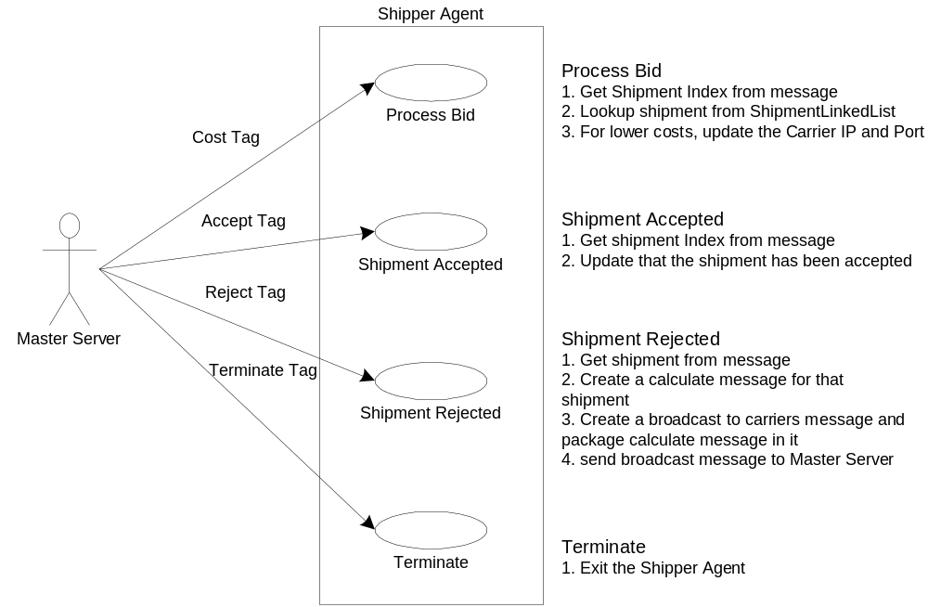
Master Server

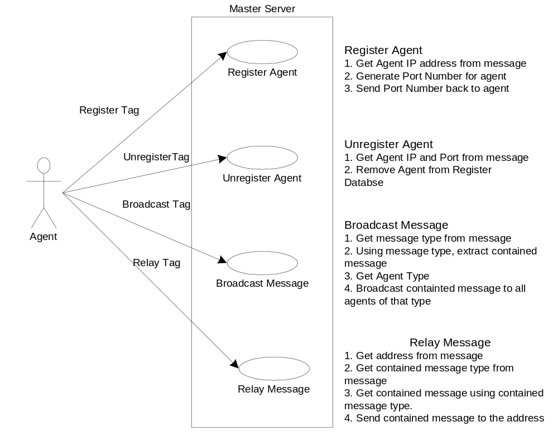
Carrier Agent
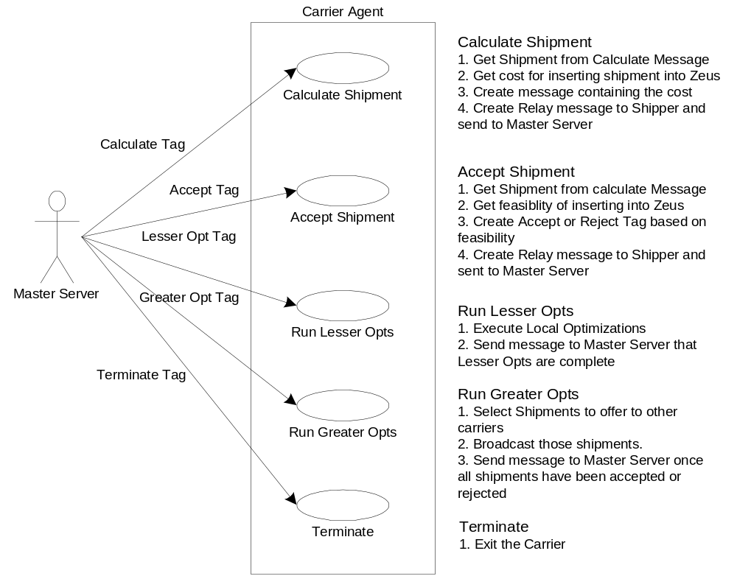
Network Diagram
